Vlm model:
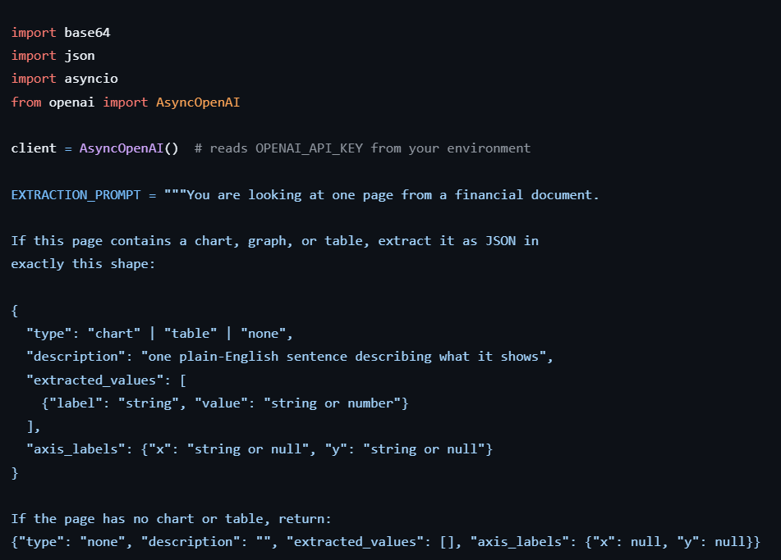
Flow steps of VLM:
- Connects to the VLM (GPT-4o) using your API key.
- Has a fixed question ready: "look at this page — if there's a chart or table, give me its type, description, values, and axis labels as JSON."
- Takes one page image and converts it to a text format (base64) so it can be sent over the internet.
- Sends the image + question to the VLM.
- Waits for the VLM's reply and reads it as JSON.
- If the reply isn't valid JSON or something goes wrong, it doesn't crash — it just returns an empty "nothing found" result for that page.
- Adds the page number to the result, so you always know which page the data came from.
- Returns the final structured result to whoever called it (extractor.py).
- A "semaphore" limits how many pages can be sent to the VLM at the same time, so it doesn't overload the API.
